**Obfuscate & DeObfuscate Steps**

**Step 1:**

Putty to TIBCO BW Server – APTIBAPP01FV with your incomm userid & login password provided to you on this server

**Step 2:**

su – tibco

**Step 3:** Change dir to /home/tibco-c/obfuscator and run ./obfuscator.ksh with below syntax:

./obfuscator –encrypt|-decrypt ‘<input text>’

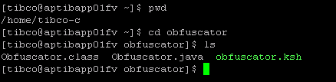

**Step 4:** Obfuscate example

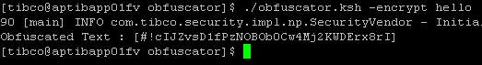

**Step 5:** De-obfuscate example

